http://www.dotnettricks.com/learn/oops/object-oriented-programming-concepts:
Object-Oriented Programming Concepts (www.dotnettricks.com)
Author : Shailendra Chauhan
Posted On : 15 Feb 2011
Updated On : 10 Jul 2012

Object-Oriented Programming Concepts
OOP is a design philosophy. It stands for Object Oriented Programming. Object-Oriented Programming (OOP) uses a different set of programming languages than old procedural programming languages (C, Pascal, etc.). Everything in OOP is grouped as self-sustainable "objects". Hence, you gain re-usability by means of four main object-oriented programming concepts. Below are object oriented programming concepts:
- Object
Object is representative of the class and is responsible for memory allocation of its data members and member functions. An object is a real world entity having attributes (data type) and behaviors (functions).
An object can be considered a "thing" that can perform a set of related activities. The set of activities that the object performs defines the object behavior. For example, the hand can grip something or a Student (object) can give the name or address
- Class
Class is a data structure that contains data members (constants files, events), member function methods, properties, constructor, destructor, indexers and nested type. Basically
- It is a user defined data type.
- It is a reference type.
- Infact class is a tag or template for object.
- Encapsulation
Encapsulation is a mechanism of binding the data member & member function into a single unit known as class. Encapsulation provides a way for abstraction. In OOP the encapsulation is mainly achieved by creating classes, the classes expose public methods and properties. The class is kind of a container or capsule or a cell, which encapsulate the set of methods, attribute and properties to provide its indented functionalities to other classes.
- Data abstraction
Data abstraction is a mechanism to provide the essential features without describing the background details. Means provide the functions to access the hidden (private) data.
The importance of abstraction is derived from its ability to hide irrelevant details and from the use of names to reference objects. Abstraction is essential in the construction of programs. It places the emphasis on what an object is or does rather than how it is represented or how it works. Thus, it is the primary means of managing complexity in large programs.
- Data Hiding
Data hiding is a mechanism to hide the internal structure of an object from rest of the program. In a class private members are hidden from the rest of the program, hence it supports data hiding. Data hiding is also a way to implement data abstraction.
- Polymorphism
Polymorphism means one thing in many forms. Basically polymorphism is capability of one object to behave in multiple ways. Example: A man role changes at home, college, and outside the home. There are following types of polymorphism:
- Static polymorphism (compile time): It is achieved using function overloading and operator overloading.
- Dynamic polymorphism (runtime time): It is achieved using function overriding means using virtual function.

Difference between function and method
In programming langauages we have two concepts functions and methods. functions are defined in structural language and methods are defined in object oriented langauge. The difference between both is given below :

Functions
- Functions have independent existence means they can be defined outside of the class. Ex:- main() function in C, C++ Language
- Functions are defined in structured languages like Pascal,C and object based language like javaScript
- Functions are called independently.
- Functions are self describing unit of code.
- //function main in C
- void main()
- {
- int a,b,c;
- a=5;
- b=6;
- c=a+b;
- printf("Sum is : %d",c);
- }

Methods
- Methods do not have independent existence they are always defined with in class. Ex:- main() method in C# Language that is defined with in a class
- Methods are defined in object oriented languages like C#, Java
- Methods are called using instance or object.
- Methods are used to manipuate instance variable of a class.
- //method sum in C#
- class demo
- {
- int a,b,c;
- public void sum()
- {
- a=5;
- b=6;
- c=a+b;
- Console.WriteLine("Sum is : {0}",c);
- }
- }

Difference between object oriented and object based languages
Object oriented and Object based programming languages have some different features and behaviour. In this article, I am going to expose the main difference between these two programming languages.

Object oriented language
- Object-oriented language supports all the features of OOPs.
- Object-oriented language doesn't has in-built object.
- Object-oriented languages are C++, C#, Java etc.

Object based language
- Object-based language doesn't support all the features of OOPs like Polymorphism and Inheritance
- Object-based language has in-built object like javascript has window object.
- Object-based languages are Javascript, VB etc.

Summary
In this article I try to expose the difference between object oriented and object based languages . I hope after reading this article you will be able to diffrentiate between these two languages. I would like to have feedback from my blog readers. Please post your feedback, question, or comments about this article.

Understanding Association, Aggregation, Composition and Dependency relationship
A relationship defines the connection between objects. This explains how objects are connected to each other’s and how they will behave.

Association
It represents a relationship between two or more objects where all objects have their own lifecycle and there is no owner. The name of an association specifies the nature of relationship between objects. This is represented by a solid line.
Let’s take an example of relationship between Teacher and Student. Multiple students can associate with a single teacher and a single student can associate with multiple teachers. But there is no ownership between the objects and both have their own lifecycle. Both can be created and deleted independently.


Aggregation
It is a specialized form of Association where all object have their own lifecycle but there is ownership. This represents “whole-part or a-part-of” relationship. This is represented by a hollow diamond followed by a line.
Let’s take an example of relationship between Department and Teacher. A Teacher may belongs to multiple departments. Hence Teacher is a part of multiple departments. But if we delete a Department, Teacher Object will not destroy.


Composition
It is a specialized form of Aggregation. It is a strong type of Aggregation. In this relationship child objects does not have their lifecycle without Parent object. If a parent object is deleted, all its child objects will also be deleted. This represents “death” relationship. This is represented by a solid diamond followed by a line.
Let’s take an example of relationship between House and rooms. House can contain multiple rooms there is no independent life of room and any room cannot belongs to two different house if we delete the house room will automatically delete.
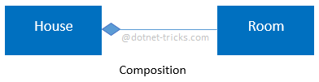
Let’s take another example of relationship between Questions and options. Single questions can have multiple options and option cannot belong to multiple questions. If we delete questions options will be automatically deleted.

Dependency
It represents a relationship between two or more objects where an object is dependent on another object(s) for its specification or implementation. This is represented by a dashed arrow.
Let’s take an example of relationship between client and service. A client is dependent on the service for implementing its functionalities.

Let’s take another example of relationship between a client and a supplier. A client is dependent on the supplier for supplying products. If the supplier will not supply the products, client cannot use those products.

Understanding Inheritance and Different Types of Inheritance
Inheritance is a mechanism of acquiring the features and behaviors of a class by another class. The class whose members are inherited is called the base class, and the class that inherits those members is called the derived class. Inheritance implements the IS-A relationship.
For example, mammal IS-A animal, dog IS-A mammal; Hence dog IS-A animal as well.

Advantages
- Reduce code redundancy.
- Provides code reusability.
- Reduces source code size and improves code readability.
- Code is easy to manage and divided into parent and child classes.
- Supports code extensibility by overriding the base class functionality within child classes.

Disadvantages
- In Inheritance base class and child classes are tightly coupled. Hence If you change the code of parent class, it will get affects to the all the child classes.
- In class hierarchy many data members remain unused and the memory allocated to them is not utilized. Hence affect performance of your program if you have not implemented inheritance correctly.

Different Types of Inheritance
OOPs supports the six types of inheritance as given below-
- Single inheritance
In this inheritance, a derived class is created from a single base class.
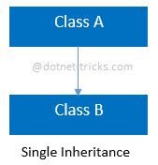
  - //Base Class
  - class A
  - {
  - public void fooA()
  - {
  - //TO DO:
  - }
  - }

  - //Derived Class
  - class B : A
  - {
  - public void fooB()
  - {
  - //TO DO:
  - }
  - }
- Multi-level inheritance
In this inheritance, a derived class is created from another derived class.
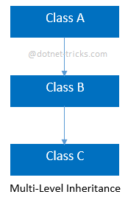
  - //Base Class
  - class A
  - {
  - public void fooA()
  - {
  - //TO DO:
  - }
  - }

  - //Derived Class
  - class B : A
  - {
  - public void fooB()
  - {
  - //TO DO:
  - }
  - }

  - //Derived Class
  - class C : B
  - {
  - public void fooC()
  - {
  - //TO DO:
  - }
  - }
- Multiple inheritance
In this inheritance, a derived class is created from more than one base class. This inheritance is not supported by .NET Languages like C#, F# etc.
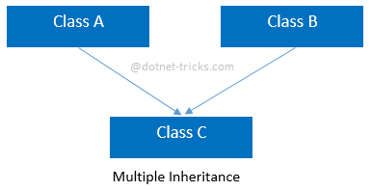
  - //Base Class
  - class A
  - {
  - public void fooA()
  - {
  - //TO DO:
  - }
  - }

  - //Base Class
  - class B
  - {
  - public void fooB()
  - {
  - //TO DO:
  - }
  - }

  - //Derived Class
  - class C : A, B
  - {
  - public void fooC()
  - {
  - //TO DO:
  - }
  - }
- Multipath inheritance
In this inheritance, a derived class is created from another derived classes and the same base class of another derived classes. This inheritance is not supported by .NET Languages like C#, F# etc.
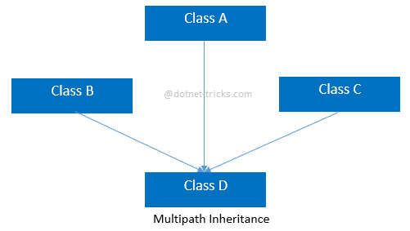
  - //Base Class
  - class A
  - {
  - public void fooA()
  - {
  - //TO DO:
  - }
  - }

  - //Derived Class
  - class B : A
  - {
  - public void fooB()
  - {
  - //TO DO:
  - }
  - }

  - //Derived Class
  - class C : A
  - {
  - public void fooC()
  - {
  - //TO DO:
  - }
  - }

  - //Derived Class
  - class D : B, A, C
  - {
  - public void fooD()
  - {
  - //TO DO:
  - }
  - }
- Hierarchical inheritance
In this inheritance, more than one derived classes are created from a single base.
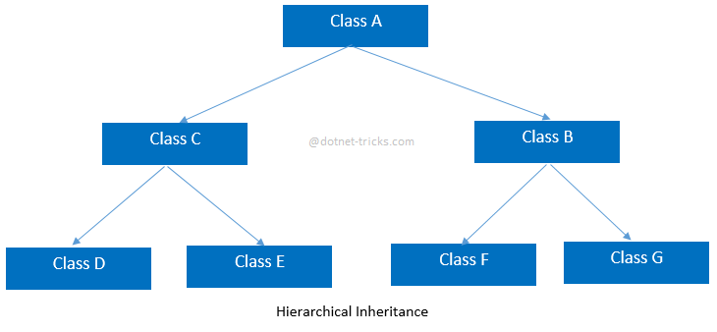
  - //Base Class
  - class A
  - {
  - public void fooA()

  - {
  - //TO DO:
  - }
  - }

  - //Derived Class
  - class B : A
  - {
  - public void fooB()
  - {
  - //TO DO:
  - }
  - }

  - //Derived Class
  - class C : A
  - {
  - public void fooC()
  - {
  - //TO DO:
  - }
  - }

  - //Derived Class
  - class D : C
  - {
  - public void fooD()
  - {
  - //TO DO:
  - }
  - }

  - //Derived Class
  - class E : C
  - {
  - public void fooE()
  - {
  - //TO DO:
  - }
  - }

  - //Derived Class
  - class F : B
  - {
  - public void fooF()
  - {
  - //TO DO:
  - }
  - }

  - //Derived Class
  - class G :B
  - {
  - public void fooG()
  - {
  - //TO DO:
  - }
  - }
- Hybrid inheritance
This is combination of more than one inheritance. Hence, it may be a combination of Multilevel and Multiple inheritance or Hierarchical and Multilevel inheritance or Hierarchical and Multipath inheritance or Hierarchical, Multilevel and Multiple inheritance.
Since .NET Languages like C#, F# etc. does not support multiple and multipath inheritance. Hence hybrid inheritance with a combination of multiple or multipath inheritance is not supported by .NET Languages.
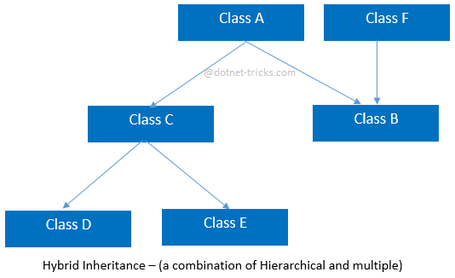
  - //Base Class
  - class A
  - {
  - public void fooA()
  - {
  - //TO DO:
  - }
  - }

  - //Base Class
  - class F
  - {
  - public void fooF()
  - {
  - //TO DO:
  - }
  - }

  - //Derived Class
  - class B : A, F
  - {
  - public void fooB()
  - {
  - //TO DO:
  - }
  - }

  - //Derived Class
  - class C : A
  - {
  - public void fooC()
  - {
  - //TO DO:
  - }
  - }

  - //Derived Class
  - class D : C
  - {
  - public void fooD()
  - {
  - //TO DO:
  - }
  - }

  - //Derived Class
  - class E : C
  - {
  - public void fooE()
  - {
  - //TO DO:
  - }
  - }

Difference Between Generalization and Specialization
The process of extracting common characteristics from two or more classes and combining them into a generalized superclass, is called Generalization. The common characteristics can be attributes or methods. Generalization is represented by a triangle followed by a line.

Specialization is the reverse process of Generalization means creating new sub classes from an existing class.
Let’s take an example of Bank Account; A Bank Account is of two types – Current Account and Saving Account. Current Account and Saving Account inherits the common/ generalized properties like Account Number, Account Balance etc. from a Bank Account and also have their own specialized properties like interest rate etc.
